

International School

Capstone Project 1
CMU-SE 450

User Story
Version 1.2
Date: December 12th, 2025

LeafSense - Coffee Leaf Disease Detection System

Created by C1SE.03
Pham Minh Trang - 28204632177
Nguyen Pham Nhat Huy - 28211100686
Nguyen Huu Thang - 28211102537
Duong Quoc Binh - 28219006390
Nguyen Huy Hoang Bao - 28219004148

User Story Review Panel Representative:

Name Signature Date
Capstone Project 1 - Mentor:

Name MSc.Truong Dinh Huy Signature Date
PROJECT INFORMATION

Project acronym | LeafSense
Project Title | Coffee Leaf Disease Detection System
Start Date | September 9 2025 | End Date |  | December 12, 2025
Lead Institution | International School, Duy Tan University
Project Mentor | MSc.Truong Dinh Huy  Email: huy.truongdinh@gmail.com  Tel: 0982132352
Scrum master / Project Leader & contact details | Pham Minh Trang  Email: pmtrang04@gmail.com  Tel: 0911855450
Partner Organization | Duy Tan University
Team members | Name |  | Email |  | Tel
28204632177 | Pham Minh Trang |  | pmtrang04@gmail.com |  | 0911855450
28211100686 | Nguyen Pham Nhat Huy |  | huy785619@gmail.com |  | 0395546300
28211102537 | Nguyen Huu Thang |  | nguyenhuuthang11@dtu.edu.vn |  | 0702377702
28219006390 | Duong Quoc Binh |  | duongquocbinh@dtu.edu.vn |  | 0932033856
28219004148 | Nguyen Huy Hoang Bao |  | bao91ndu1819@gmail.com |  | 0385092839

DOCUMENT APPROVALS
The following signatures are required for approval of this document.
MSc.Truong Dinh Huy  Mentor | Signature | Date
Pham Minh Trang  Student ID: 28204632177  Project Leader | Signature | Date
Nguyen Pham Nhat Huy  Student ID: 28211100686  Team Member | Signature | Date
Nguyen Huu Thang  Student ID: 28211102537  Team Member | Signature | Date
Duong Quoc Binh  Student ID: 28219006390  Team Member | Signature | Date
Nguyen Huy Hoang Bao  Student ID: 28219004148  Team Member | Signature | Date

DOCUMENT NAME
Document Title | User Story
Author(s) | Nguyen Huy Hoang Bao
Role | Team Member
Date | December 12, 2025 | File name: | 4 C1SE.03_UserStory_Ver1.2.doc

REVISION HISTORY
Version | Date | Comments | Author | Approval
1.0 | September 9, 2025 | Create Document | Bao
1.1 | October 8, 2025 | Update Document | Bao
1.2 | December 12, 2025 | Official Document | Bao

Table of Contents
1. Introduction 1
1.1. Document Overview 1
1.2. Business values 2
2. Use Case of “Coffee Leaf Disease Detection System“ 3
3. User Stories 4
3.1. Admin 4
3.2. Farmer 5
3.2. Development team 8
4. Table User Stories Priority 9

1. Introduction
In the field of software development, User Stories are widely used in Agile methodology to describe the needs of end-users in a natural, non-technical language. They capture the “who”, “what”, and “why” of a requirement in a concise way, making them easy to understand and prioritize. By working closely with users to create user stories, the development team can better understand the required functionality and ensure the system meets real-world needs.
In this application, the main function is to help farmers, cooperatives, researchers, and agricultural organizations detect coffee leaf diseases early, classify severity, and receive treatment recommendations with the support of Artificial Intelligence (AI). User stories will describe key features such as image uploading, AI-based disease detection, treatment guidance, history tracking, reporting, and chatbot advice, while also covering non-functional requirements such as security, usability, and performance.

1.1. Document Overview
This document provides a user story and goal-oriented view of the LeafSense – Coffee Leaf Disease Detection System project. It highlights several key benefits:
- It answers the question: “What does this project do?” for users including farmers, cooperatives, researchers, and administrators.
- It defines the current and target system capabilities needed to support AI-based agricultural disease diagnosis.
- It clarifies required functionalities such as image upload, disease detection, severity classification, explainability, reporting, and treatment recommendations.
- It provides a useful reference that facilitates communication between the development team and stakeholders such as agricultural experts, farming communities, and academic mentors.

1.2. Business values
Our team recommends building the LeafSense application with special features to enhance agricultural productivity and decision-making:
- Support farmers and cooperatives by enabling early detection of coffee leaf diseases through AI-powered analysis.
- Provide treatment recommendations (organic, chemical, biological) to help reduce crop losses and improve sustainability.
- Allow researchers to manage datasets, export results, and continuously improve AI models for higher accuracy.
- Enable administrators to manage users, ensure data security, and maintain system stability.
- Offer a user-friendly, multilingual, and secure platform that empowers agricultural communities to share knowledge and best practices.

2. Use Case of “Coffee Leaf Disease Detection System“

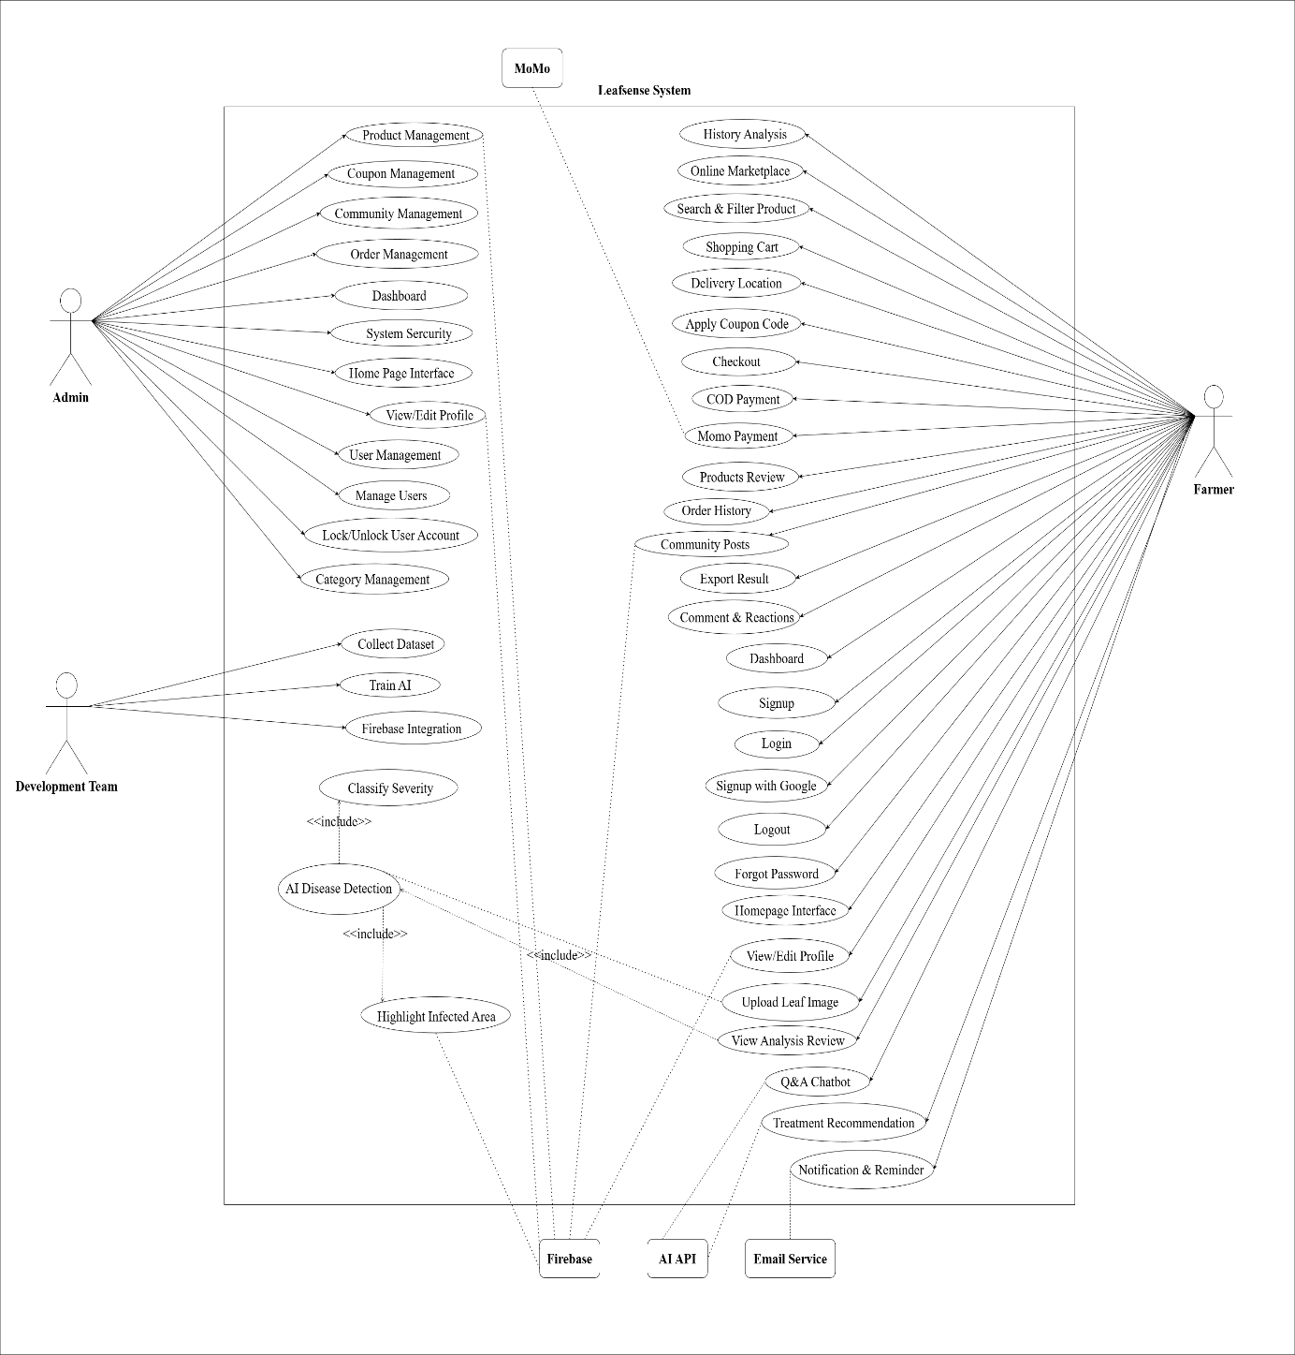
Figure 1. Use Case of “Coffee Leaf Disease Detection System“

3. User Stories

3.1. Admin
Table 1. Use Case of “Coffee Leaf Disease Detection System“ (Admin)
ID | As a/an | I want to | So that | Acceptance Criteria
US01 | Admin | See the home page | Explore all services | Page loads <3s; main navigation  visible; no 404/500.
US02 | Admin | View my personal information | Manage account information | Shows name/email/  role; data matches  DB; no sensitive data (password) exposed.
US03 | Admin | Delete farmer accounts | Maintain access control | Delete requires confirmation; account  disabled/removed; user cannot log in; deletion event logged.
US04 | Admin | Add, edit, delete categories | Keep marketplace organized | CRUD list works properly, save DB successfully
US05 | Admin | Add, edit, delete products | Keep data accurate and updated | Create/update/delete with required fields  (name, price, stock); updates visible  immediately;negative  price/stock blocked.
US06 | Admin | Manage coupon codes | Run discount programs effectively | Create/update/disable codes; configure  value, expiry, conditions; expired codes unusable; discount calculated correctly.
US07 | Admin | Edit my personal information | Keep my data up to date | Update name/phone/  avatar succeeds; input validated; changes visible immediately; password never exposed.
US08 | Admin | View and update order statuses | Ensure on-time delivery | See orders with statuses; can set pending/shipping/completed/cancelled; changes persist and visible to customers; status changes logged.
US09 | Admin | Censor or delete offending posts | Maintain a safe community environment | Can hide/delete posts; moderation reason recorded; hidden posts not shown to users;  action logged.
US10 | Admin | View system statistics | Monitor users, posts, and orders | Dashboard shows user/post/order counts and revenue summary; loads <3s; admin-only access.
US11 | Admin | Lock or unlock farmer accounts | Restrict users violating policies | Lock/unlock works; locked users cannot log in; status shown to user; action logged.

3.2. Farmer
Table 2. Use Case of “Coffee Leaf Disease Detection System“ (Farmer)
ID | As a/an | I want to | So that | Acceptance Criteria
US01 | Farmer | Sign up for a new account | Access LeafSense features | Sign up validates required fields and unique email; password policy is enforced; successful submission confirms and creates an account; error messages are clear and user-friendly.
US02 | Farmer | Log in to my account | Secure system access | Valid credentials  grant access; invalid blocked with message; session created; redirects to  home/dashboard.
US03 | Farmer | Sign in with my Google account | Save time | OAuth flow  succeeds or fails with clear message; first-time users created; returns logged-in session.
US04 | Farmer | Log out of my account | Keep my account safe | The login session is deleted and the user is securely logged out.
US05 | Farmer | Reset my password | Regain secure access | Password reset email sent and updated successfully.
US06 | Farmer | See the home page | Explore all services | Page loads <3s; main navigation visible; no 404/500.
US07 | Farmer | View my personal information | Manage my account information | Shows name/email/  phone/avatar; data matches DB; no sensitive fields  (password).
US08 | Farmer | Upload coffee leaf images for analysis | Automatically detect leaf disease | Accepts camera/  gallery; validates  format/size; upload  succeeds over HTTPS; shows progress  and success/failure.
US09 | Farmer | See disease name, severity, and reliability | Treat plants in time | Results show disease type, accuracy %, disease area
US10 | Farmer | Receive treatment recommendations based on results | Take care of my plants more efficiently | Shows actionable steps tied to detecteddisease; loaded with detection result; offline/error handled gracefully.
US11 | Farmer | Review old analysis | Coffee plant health monitoring | Lists past analyses with date/  result; can open detail; pagination/  search works.
US12 | Farmer | Browse product list | Select agricultural supplies to buy | Product grid/list  loads with name/  price/stock; filters/sort work; performance acceptable (<3s).
US13 | Farmer | Find products by name or category | Quickly and accurately find products | Search by keyword; filter by category; results relevant and up to date.
US14 | Farmer | Add, remove, or update products in my cart | Manage what I want to buy before checkout | Add/remove/update quantity; totals recalc immediately; prevents negative/  over-stock quantities.
US15 | Farmer | Select my delivery address on the map | Ensure accurate delivery | Map loads; can pick/search  address; address saved with  order; validation  prevents empty/  invalid.
US16 | Farmer | Enter a discount code at checkout | Get discounts on my orders | Valid code applies correct discount; expired/invalid  blocked with  message; cannot  stack unsupported  combos.
US17 | Farmer | Edit my personal information | Keep my data up to date | Update name/phone/avatar; validation; changes saved and reflected; password not exposed.
US18 | Farmer | Review order and confirm payment | Complete my purchase process | Order summary  shows items/price  /discount/shipping/  address; confirmation recordsorder and status; errors are clear.
US19 | Farmer | Choose cash on delivery | Pay after receiving goods successfully | COD option  selectable; fee (if any) shown; order stored with  COD status; instructions shown.
US20 | Farmer | Pay using MoMo wallet | Complete transactions quickly | MoMo option available; successful payment updates order to paid; failures show error and order stays unpaid; receipt stored.
US21 | Farmer | Rate and comment on purchased products | Share experiences with others | Only for purchased items; rating 1–5 and comment saved; edits/deletes logged; shows in product reviews.
US22 | Farmer | View my previous orders | Track order status and payments | Order list with status, totals, payment method; can open details; pagination works.
US23 | Farmer | Create a community post | Share experiences and knowledge | Create post with title/body/media; validation; visible after submit; inappropriate contentcheck basic  (e.g., size/type).
US24 | Farmer | Comment or react to posts | Interact with others in the community | Add comment/react;can delete own comment; handles failure  gracefully.
US25 | Farmer | Ask questions about coffee leaf symptoms | Get instant AI feedback | Input question/text AI returns answer or asks for clarification; errors/timeouts  surfaced clearly.
US26 | Farmer | View my activity overview | Easily manage my activities | Dashboard shows  recent analyses, orders, posts, and notifications; loads <3s; links navigate to details.

3.2. Development team
Table 4. Use Case of “Coffee Leaf Disease Detection System“ (Development team)
ID | As a/an | I want to | So that | Acceptance Criteria
US01 | Development Team | Collect and label coffee leaf photos | Train accurate AI models | The dataset has 4 classes (Rust, Phoma, Miner, Nodisease), quality images, labeled & saved in the correct structure.
US02 | Development Team | Train AI to identify coffee leaf diseases | The system can accurately classify diseases on coffee leaves. | Using dataset from Roboflow, training on Google Colab;start/monitor training jobs; training  config saved (hyperparameters); results  metrics recorded  (accuracy/loss); model artifact  versioned and  retrievable.
US03 | Development Team | To securely store uploaded images and retrieve them quickly via Firebase | Image access is fast, reliable, and URLs can be safely reused across the application | Images are uploaded successfully to Firebase Storage;A download URL is generated after upload;The image URL is saved in the database;The saved URL can be retrieved and used to display the image;Image access is fast and does not fail on page reload

4. Table User Stories Priority
Table 5. Table user story priority
User Story ID | User Story Name | Priority | Product Backlog ID
Admin
01 | Home page interface(Admin) | 2 | PB-01
02 | View profile(admin) | 3 | PB-02
03 | User management | 1 | PB-03
04 | Category management | 2 | PB-04
05 | Product management | 1 | PB-05
06 | Coupon management | 2 | PB-06
07 | Edit profile | 2 | PB-07
08 | Order management | 1 | PB-08
09 | Community management | 1 | PB-09
10 | Dashboard(Admin) | 1 | PB-10
11 | Lock/Unlock farmer accounts | 1 | PB-11
Farmer
01 | Sign up | 1 | PB-01
02 | Log in | 1 | PB-02
03 | Sign in with Google | 2 | PB-03
04 | Log out | 2 | PB-04
05 | Forgot password | 2 | PB-05
06 | Home page interface(Farmer) | 2 | PB-06
07 | View profile | 3 | PB-07
08 | Upload leaf image | 1 | PB-08
09 | View analysis results | 1 | PB-09
10 | Treatment recommendations | 1 | PB-10
11 | Historical analysis | 2 | PB-11
12 | Online marketplace | 1 | PB-12
13 | Search & filter products | 2 | PB-13
14 | Shopping cart | 1 | PB-14
15 | Delivery location (Google Map) | 1 | PB-15
16 | Apply coupon code | 2 | PB-16
17 | Edit profile | 2 | PB-17
18 | Checkout | 1 | PB-18
19 | COD payment | 1 | PB-19
20 | MoMo payment | 1 | PB-20
21 | Product reviews | 2 | PB-21
22 | Order history | 2 | PB-22
23 | Community posts | 2 | PB-23
24 | Comments & reactions | 2 | PB-24
25 | Q&A Chatbot | 2 | PB-25
26 | Dashboard | 1 | PB-26
Development Team
01 | Collect dataset | 1 | PB-01
02 | Train AI | 1 | PB-02
03 | Firebase Integration | 1 | PB-03

